Fill your heart as you fill your tummy
By: Sharon Elango
Giving back to the society just by having scrumptious food on your table.

Who knew that you can take your insta-worthy café-hopping shots and at the same time help someone? Founded in Dec, 2013, Crossings Café is a social enterprise that provides jobs for students with special needs. Profits from the cafe are also donated to charities for a good cause.

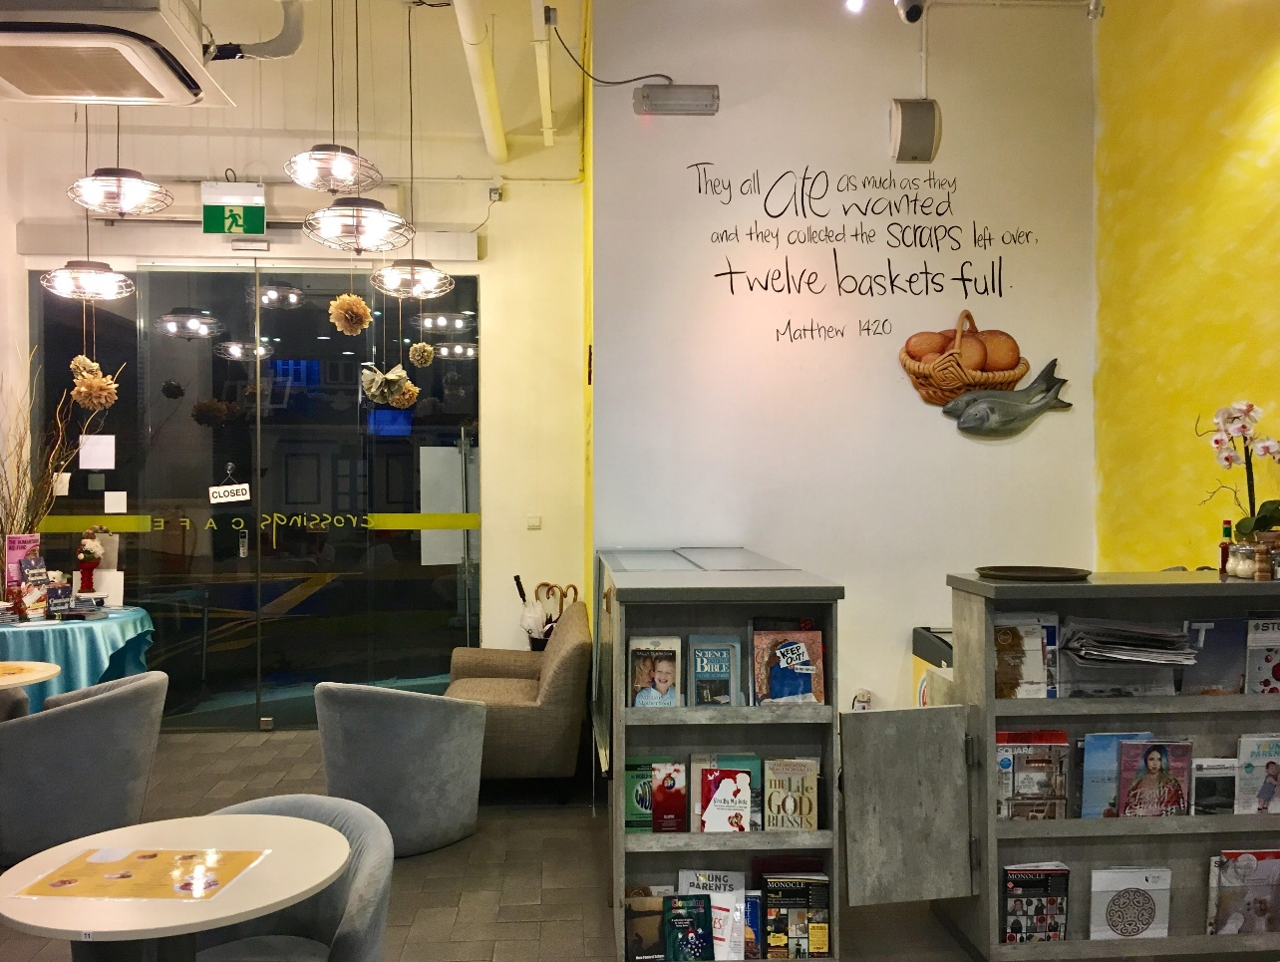
FOOD WITH A CAUSE: With interns from Assumption Pathway School, Crossings Café helps disadvantaged students hone their F&B skills. PHOTO BY: SHARON ELANGO

Crossings Café has a very cosy and welcoming ambience. Even though the café has Bible verses plastered on their walls, they play mainstream music which anyone could enjoy. There are also magazines to accompany customers while they are waiting for their food. Their staff were polite and cheerful always engaging their customers. As I was talking to their staff, one of their barista, Ahmad Irfan, 25 said: “We work here as a family and not just any other team. Sometimes I feel like giving up but my employers give me a lot of courage and tell me to press on,” – This instantly impressed me.
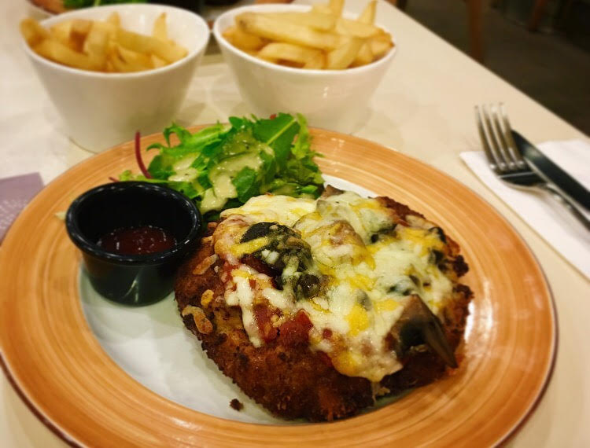
HIDDEN GEM: In Crossings Café, the Chicken Mushroom Parmigiana is often overlooked but it definitely deserves a second glance. The meat was thick and worth every penny. PHOTO BY: SHARON ELANGO

The chicken was tender and crispy and the portion was huge. If you are not worried about gaining a bit of weight, this should be your go to. The salad which accompanied the chicken was crisp. On the downside, I felt that the cheese was not evenly distributed. There were some parts of the chicken without cheese. The Chicken Parmigiana came along with a stack of fries too and the dish cost $16 (w/o GST and service charge).
Verdict: 7.5/10
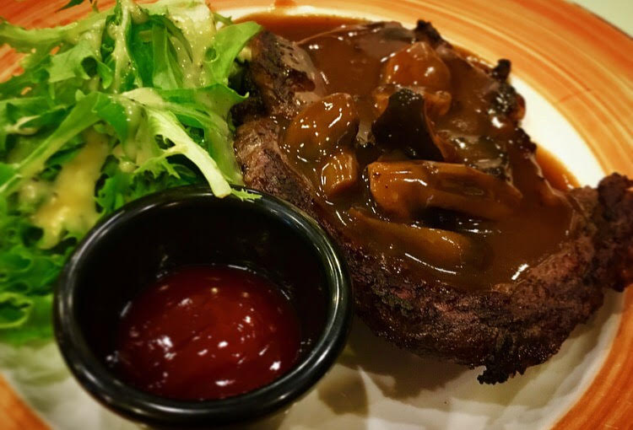
THAT SIZZLE WILL MAKE YOU TWIZZLE: On top of just looking great, the mushroom sauce on top of the steak will make you come back for more. PHOTO BY: SHARON ELANGO

There was an ongoing promotion in Crossings Café which was the Australian Ribeye Steak with Mushroom Sauce together with the Soup of the Day. It was also served with fries and salad and it was $20 (w/o GST and service charge). The waiter who took our orders warned us that the steak will be in a medium size as we were ordering a meal instead of A-la-Carte but we still carried on with it. The meat was tender and juicy and the mushroom sauce had a delicate aroma and a savoury taste.
Verdict: 8/10
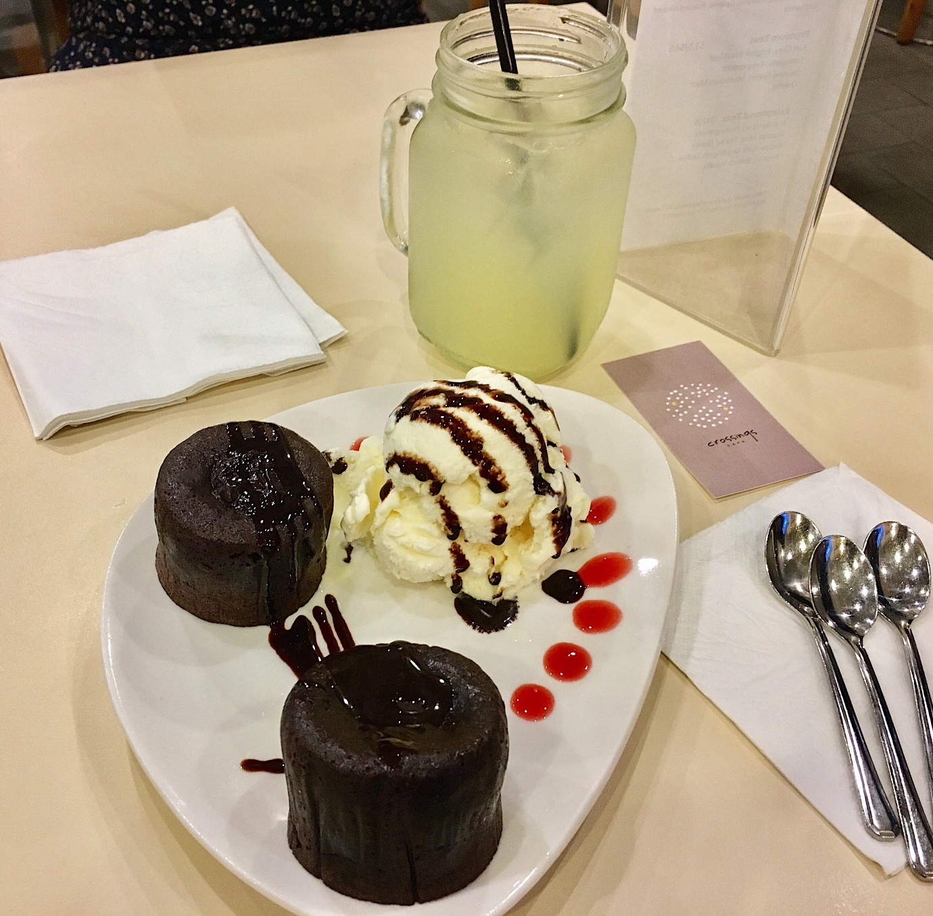
GUILTY PLEASURE: With an array of desserts, you will be spoiled for choice when picking your dessert but who can resist the popular molten cake? PHOTO BY: SHARON ELANGO

There is always room for dessert! Our dessert was served within 3 minutes after we were done with our mains. I ordered a Molten Cake and I was surprised to see 2 molten cakes instead of 1. It felt great to end my rainy Saturday with a warm, moist and fudgy molten cake which cost $9 (w/o GST and service charge).
Verdict: 9/10

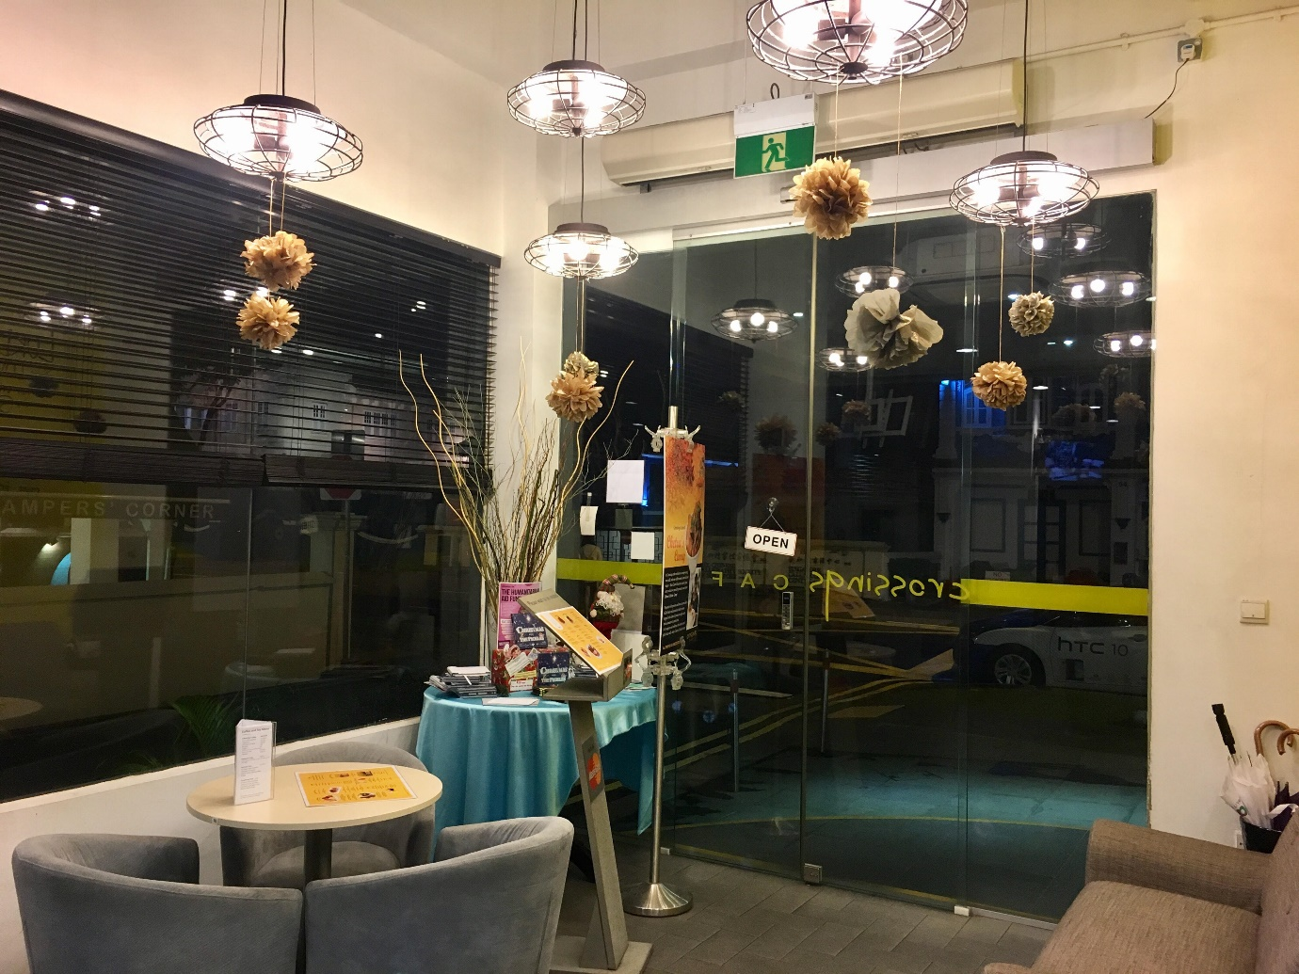
SIMPLE AND COZY: With such a comfy environment, Crossings Café will be an ideal place to have a hearty meal and a catch up session with your friends. PHOTO BY: SHARON ELANGO

A customer from Crossings, Grace Abraham, 48, said: “The food is slightly expensive but I have no regrets paying that much because I know by eating here, I am helping someone.” Food with a cause, why not just head down to Crossings and play your part in changing someone’s life?

Conveniently located at Waterloo Street, Crossings café is just a few minutes’ walk from Bras Basah MRT Station (Exit E).
ADDRESS:
55 Waterloo Street
Singapore 187954
OPENING HOURS:
Weekends:
10:00am - 10:00pm
Weekdays:
08:00am - 10:00pm
PHONE:

+65 63366203
WEBSITE:
http://crossingscafe.com.sg/

